DC Fast Charging Station
User Manual

Power Range: 240kW - 480kW
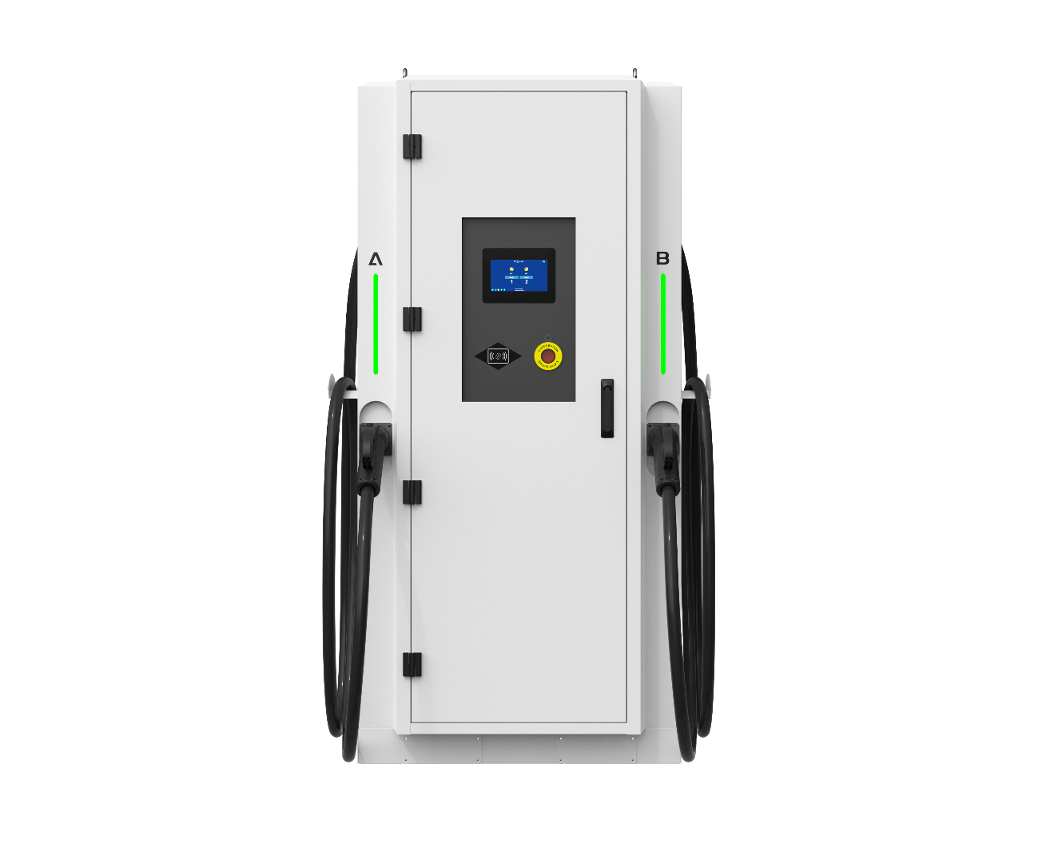

Manufacturer: Willdigits
Series Model: 240-480kW
Release Date: 2025-01-11
Version: V1.0
www.willdigits.com
Table of Contents
1. Important Safety Instructions 3
2. Product Introduction 5
3. Technical Specifications 9
4. Unpacking and Inspection 10
5. Installation Guide 11
6. Operating Instructions 24
7. Description of Indicator Lights, HMI, and Operations Platform 27
8. Charging Modes Description 36
9. Maintenance and Care 37
10. Troubleshooting 39
11. Warranty Information 45
12. Appendix 48

1. Important Safety Instructions

1.1 General Safety Warnings
● DANGER: HIGH VOLTAGE! This equipment operates with high voltage. Contact with live internal parts may result in electric shock, burns, or death.
● Installation and maintenance must be performed by trained and certified electricians or professional technicians holding local qualifications.
● Do not disassemble or modify the charging station housing or internal structure without authorization.
● Read and understand this manual completely before operation.

1.2 Electrical Safety Requirements
● Must Have Reliable Grounding: The charging station must be connected to a protective earth (PE) system that complies with local electrical codes.
● Upstream Protection: A properly rated circuit breaker must be installed on the power supply line ahead of the charging station.
● Cable Requirements: Input cables must be copper core with cross-sectional area sufficient for the maximum current demand of this equipment, considering voltage drop.

1.3 Environmental Safety
● DO NOT USE in Explosive Atmospheres: Do not operate this equipment in the presence of flammable, explosive gases, vapors, or dust.
● Keep Away from Water: Do not immerse the charging station in water. Although the unit has an ingress protection rating (IP54/IP55), avoid installing in areas prone to standing water or frequent water spray.
● Ventilation Requirements: This equipment generates heat during operation. Ensure adequate clearance around the unit for heat dissipation (typically left/right ≥1000mm, rear ≥200mm, front ≥1000mm).
● Operating Temperature: Ensure ambient temperature is within the equipment's allowable operating range (typically -30°C to +70°C).

1.4 Operational Safety
● Inspect Connector: Before each charge, inspect the charging gun and cable for damage, foreign objects, or moisture. Do not use if damaged.
● Proper Plugging/Unplugging: Hold the gun body when plugging or unplugging. Never pull on the cable.
● Keep Hands Dry: Do not plug/unplug the charging gun or touch the touchscreen with wet hands.
● Supervise Children: Keep children away from the charging gun and cable during operation.
● Emergency: In case of fire, electric shock, or other emergency, immediately press the red emergency stop button and disconnect the upstream power supply.

1.5 Electromagnetic Compatibility
This equipment complies with relevant electromagnetic compatibility standards (e.g., IEC 61851-21-2). Individuals with implanted medical devices such as pacemakers should consult their physician and maintain a safe distance before use.

2. Product Introduction

2.1 Product Overview
This series is a high-power DC fast charging station designed to provide rapid DC charging for electric buses, logistics vehicles, passenger cars, and more. The output power range is 60kW to 240kW, automatically adjusting according to the vehicle battery management system (BMS) requirements. Suitable for public charging stations, bus depots, highway service areas, fleet parking lots, etc.

2.2 Key Features
● High Efficiency: Efficiency ≥95%, reducing operating costs.
● Dual Gun Simultaneous/Alternating Charging: Supports charging two vehicles simultaneously with dual guns, or high-power charging with a single gun (depending on configuration).
● Smart Control: Supports various activation methods including RFID card, mobile APP, QR code, etc.
● Multiple Communication Interfaces: Standard with Ethernet, 4G wireless; optional OCPP protocol for easy integration with operation platforms.
● Modular Design: Power modules are hot-swappable for easy maintenance.
● Safety Protection: Multiple protections including overvoltage, undervoltage, overcurrent, short circuit, leakage, lightning protection, and overtemperature.

2.3 Exterior and Component Identification
(Insert product front view, side view, rear view diagrams or photos here with leader lines indicating the following components)
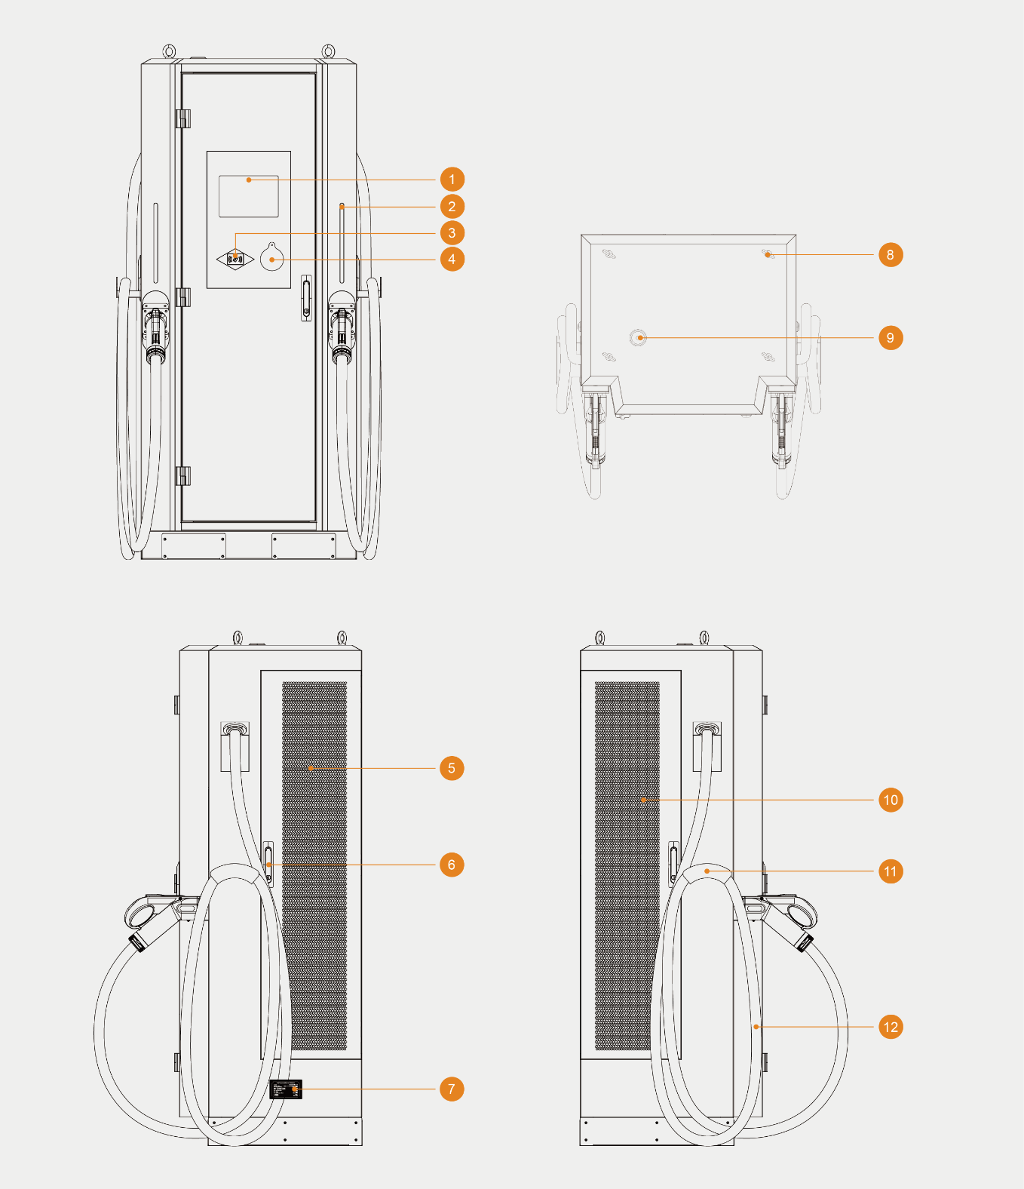
No. | Component | Function Description
1 | Touchscreen Display | Human-machine interface for information display, parameter settings, charging operations
2 | Status Indicator Lights | Indicate equipment status: Standby/Connected/Charging/Fault
3 | RFID Reader | Card swipe area (if equipped)
4 | Emergency Stop Button | Press in emergency to immediately cut off output (red mushroom head)
5 | Cooling Fan Inlet | Forced air cooling exhaust Inlet — DO NOT BLOCK
6 | Door Handle | Handle for opening the front/maintenance door
7 | Nameplate | Model, power, voltage, current, serial number, certifications, etc.
8 | Lifting / Mounting Rings | Integrated hoist rings on top for lifting the unit during installation.
9 | Router Antenna | External antenna for 4G/Wi-Fi signal enhancement
10 | Cooling Fan Outlet | Forced air cooling exhaust Outlet — DO NOT BLOCK
11 | Gun Holster/Holder | For temporarily holding the charging gun when not in use
12 | Charging Gun A/B | DC charging gun (CCS2 / CHAdeMO / GB/T / NACS selectable per market)

2.4 Charging Connector Types
This series can be configured with one or more of the following charging interfaces according to order requirements:
 | CCS2 (Combo 2) | Compliant with IEC 62196-3, for European market.
 | CCS1 (Combo 1) | Compliant with North American standards.
 | CHAdeMO | Compliant with Japanese standards.
 | GB/T (DC) | Compliant with Chinese national standards.
 | NACS | North American Charging Standard.
Note: Refer to the markings on the unit for the specific connector type installed.

2.5 Connector combination method
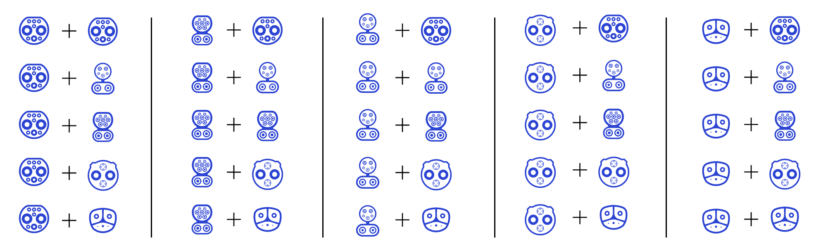
All connector types are freely combinable.

3. Technical Specifications
Parameter | 240kW Model | 320kW Model | 360kW Model | 400kW Model | 480kW Model
Input Characteristics
Input Voltage | 400V AC ±15% (3-phase, 5-wire)
Input Frequency | 50/60Hz
Max Input Current | Approx. 480A | Approx. 640A | Approx. 720A | Approx. 800A | Approx. 960A
Power Factor | ≥0.99
Output Characteristics
Output Voltage Range | 150V - 1000V DC
Max Output Current | 300A / 600A* | 400A / 800A* | 400A / 800A* | 400A / 800A* | 400A / 800A*
Max Power per Gun | 240kW | 320kW | 360kW | 400kW | 480kW
Dual Gun Allocation | Equal / Dynamic
Efficiency & Losses
Full Load Efficiency | ≥95%
Standby Power | <50W
General Parameters
Enclosure Material | Sheet metal painting/Stainless steel(optional)
Ingress Protection | IP54 (IP55 optional)
Operating Temperature | -30°C to +75°C
Storage Temperature | -40°C to +75°C
Relative Humidity | 5% to 95% non-condensing
Cooling Method | Forced air cooling
Noise Level | <65dB @1m
Dimensions (H*W*D) | Net dimensions (1900*900*700 mm) packaging dimensions (2150*1200*850 mm)
Net Weight | 400kg | 450kg | 475kg | 500kg | 550kg
Gross Weight | 425kg | 475kg | 500kg | 525kg | 575kg
Cable Length | 5m (4-7m optional)
Certification Standards
Applicable Standards | CE ( UKCA / UL optional)
Safety Standards | IEC 61851-1, -23
EMC | IEC 61851-21-2
*Note: * Current value depends on output voltage and configuration. Refer to the nameplate on the unit for exact specifications.

4. Unpacking and Inspection

4.1 Transportation and Storage
● Avoid severe impact, vibration, and rain during transportation.
● For long-term storage, keep in a dry, non-corrosive gas, dust-free environment at -40°C to +70°C.

4.2 Unpacking Procedure
1. Remove external packaging.
2. Inspect the equipment exterior for any visible damage, dents, scratches, or deformation caused by transportation.
3. Check all components (door locks, display, charging gun holders, etc.) for integrity. Ensure doors open and close smoothly.
4. Verify accessories against the packing list.

4.3 Packing List
No. | Item | Qty | Remarks
1 | DC Charging Station Main Unit | 1
2 | User Manual | 1
3 | Certificate of Quality | 1
4 | Warranty Card | 1
5 | Keys (if door lock equipped) | 2
6 | Installation Accessory Kit | 1 set | Includes expansion bolts, screws, etc.
7 | Pedestal/Mounting Pole (if optional) | 1 set | For floor-standing installation
8 | Spare Fuses | Several
Note: Verify against actual delivery packing list. If any items are missing or damaged, contact the carrier and supplier immediately.
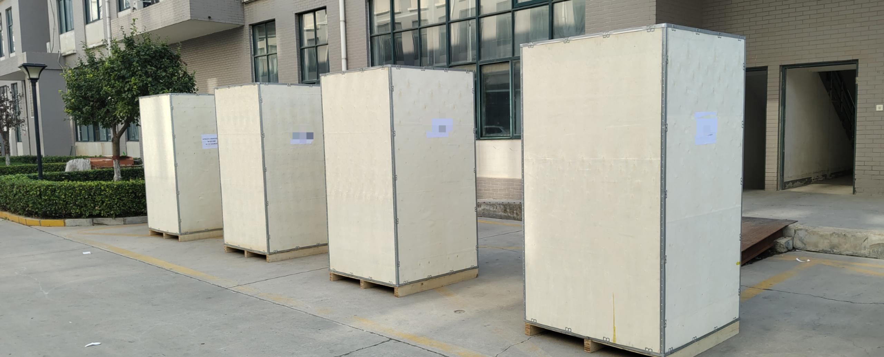
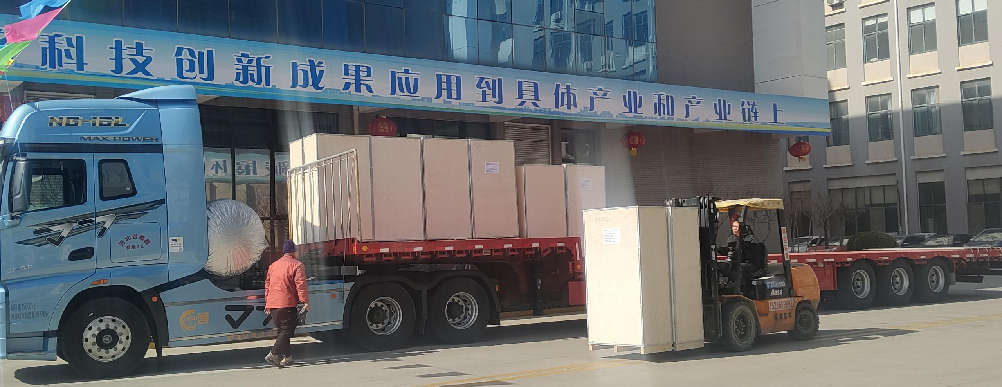

5. Installation Guide

5.1 Pre-Installation Preparation
WARNING: Ensure upstream power is disconnected and locked out before installation to prevent accidental energization.

5.1.1 Tools Required
Electrical Tools | Multimeter | 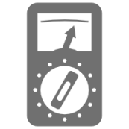
Electrical Tools | screwdriver set (slotted, Phillips) | 
Electrical Tools | wire strippers | 
Electrical Tools | crimping tool | 
Electrical Tools | torque wrench | 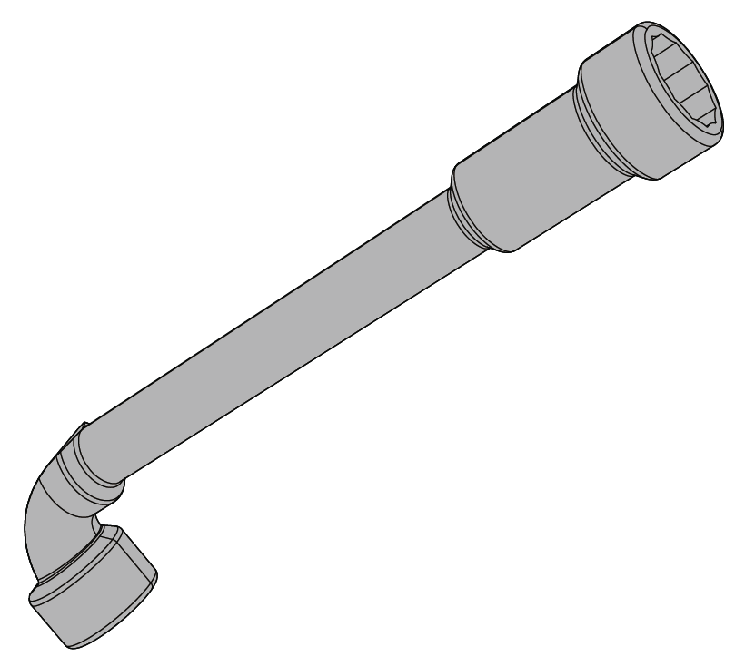
Electrical Tools | Knife | 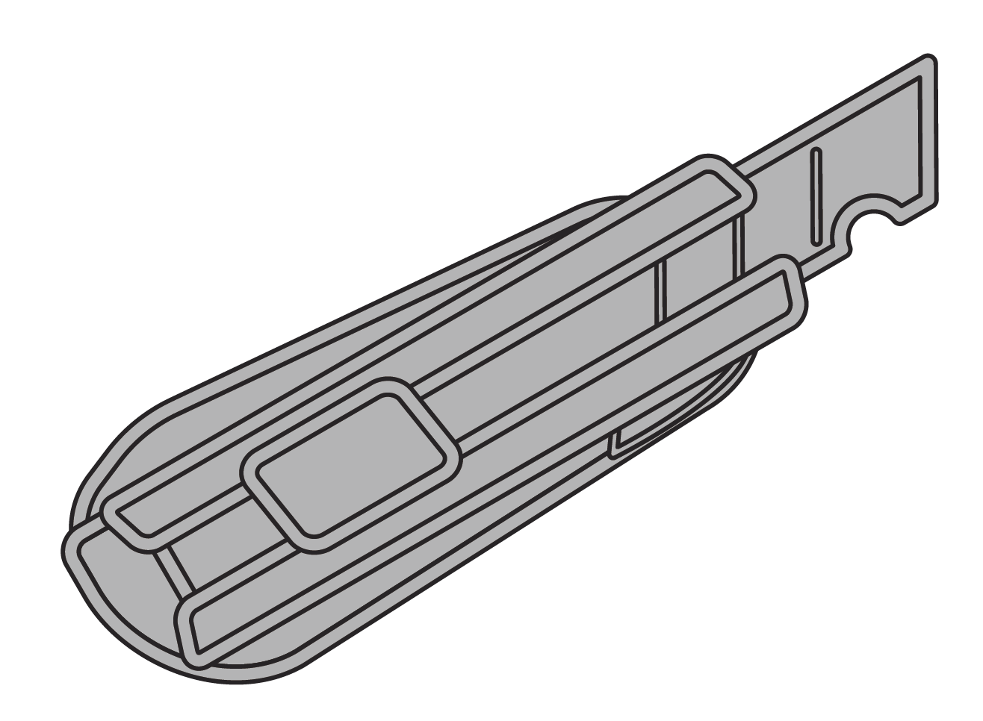
Electrical Tools | Cutting pliers | 
Electrical Tools | Cable crimper | 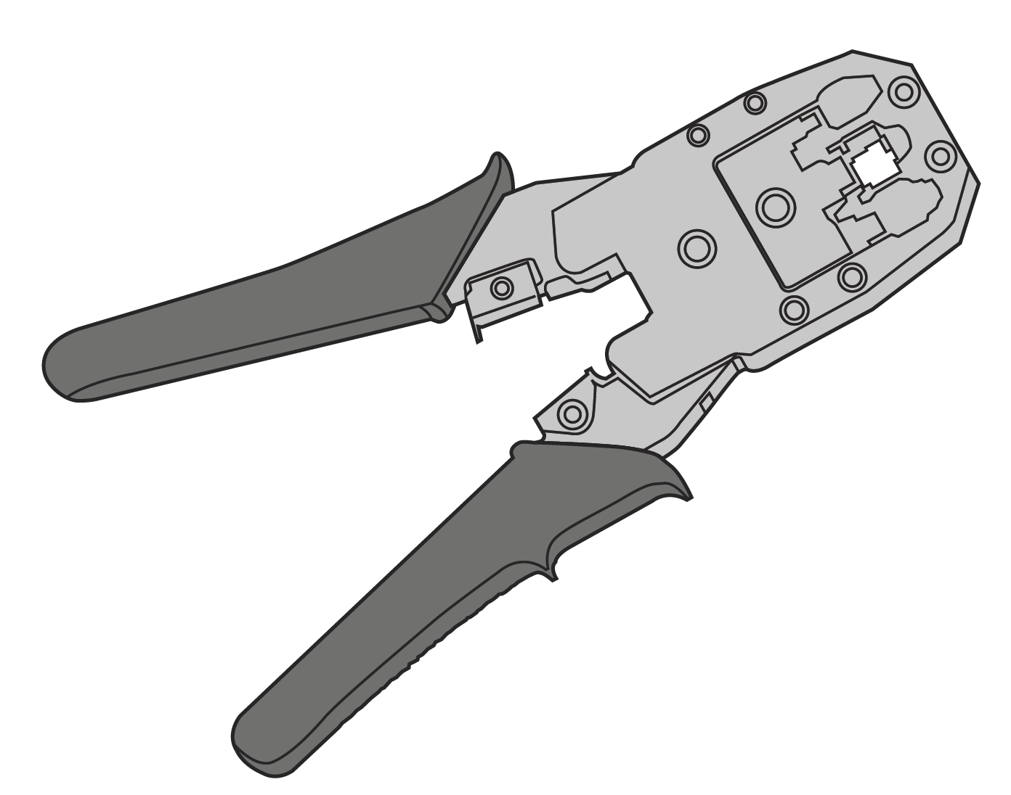
Mechanical Tools | Hammer drill | 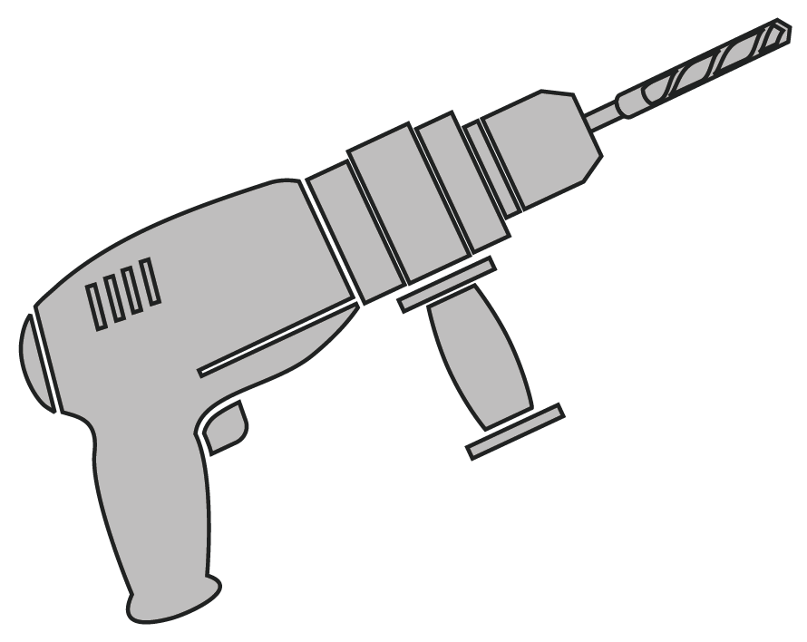
Mechanical Tools | spirit level | 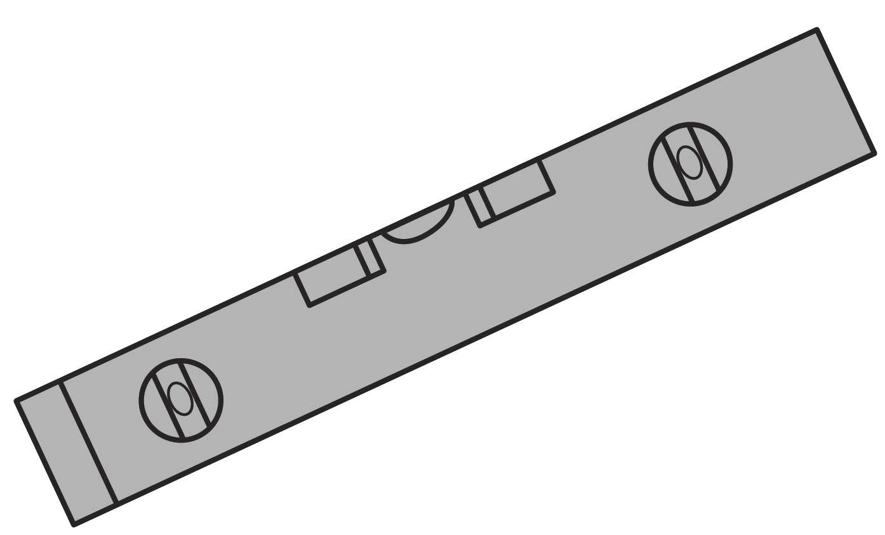
Mechanical Tools | tape measure | 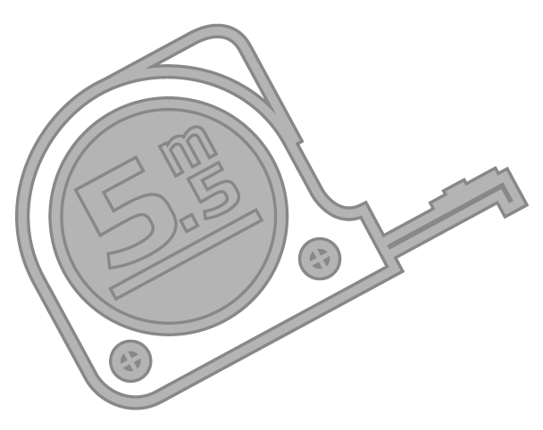
Mechanical Tools | marking pen | 
Mechanical Tools | Electrical screwdriver | 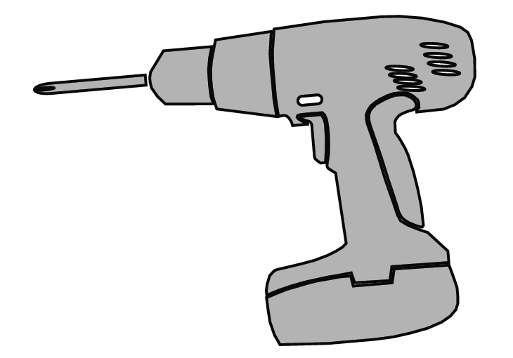
Mechanical Tools | Hammer | 
5.1.2 Site Selection Confirmation
● Space Requirements: Ensure sufficient operating space in front of the unit (≥1000mm), and clearance on sides and rear for heat dissipation (≥1000mm sides, ≥200mm rear). Do not block the top.
● Surface Load Capacity: The mounting surface must be solid, level, and capable of bearing the equipment weight (see Chapter 3). For floor-standing installation, a concrete foundation is required.
● Environmental Requirements: Avoid low-lying areas prone to flooding, excessive direct sunlight, proximity to heat sources, or corrosive gases. Prefer sheltered locations.
● Network Signal: Verify 4G/Wi-Fi signal strength at the installation site meets remote communication requirements.
5.1.3 Electrical Conditions Verification
● Supply Capacity: Verify upstream transformer and line capacity meet the maximum power demand of this equipment.
● Input Voltage: Use a multimeter to verify input voltage is 400V AC ±15% (3-phase, 5-wire).
● Circuit Breaker Rating: Install appropriately rated circuit breaker based on equipment power.
○ 240kW: ≥500A
○ 320kW: ≥630A
○ 360kW: ≥630A
○ 400kW: ≥800A
○ 480kW: ≥2*500A
● Cable Specifications: Input cables must be copper core with temperature rating ≥90°C. Recommended cross-sections (for reference only — calculate voltage drop based on actual distance and local codes):
○ 240kW: 2*(3x95mm² + 2x50mm²)
○ 320kW: 2*(3x120mm² + 2x70mm²)
○ 360kW: 2*(3x150mm² + 2x70mm²)
○ 400kW: 2*(3x185mm² + 2x95mm²)
○ 480kW: 2*(3x185mm² + 2x95mm²)
● Grounding System: Verify grounding resistance meets local codes (typically ≤4Ω). PE must be reliably connected.

5.2 Installation Procedure
5.2.1 Foundation Preparation and Conduit Embedment (Floor-Standing)
1. Prepare concrete foundation according to equipment base dimensions (recommended size: length x width = equipment base + 100mm, depth ≥500mm or based on local frost line).
2. Embed conduit (recommended diameter ≥100mm) emerging from foundation center. Conduit end should protrude ≥50mm above foundation level to prevent water ingress.
3. Embed anchor bolts or reserve holes for expansion bolts, matching equipment base hole positions.
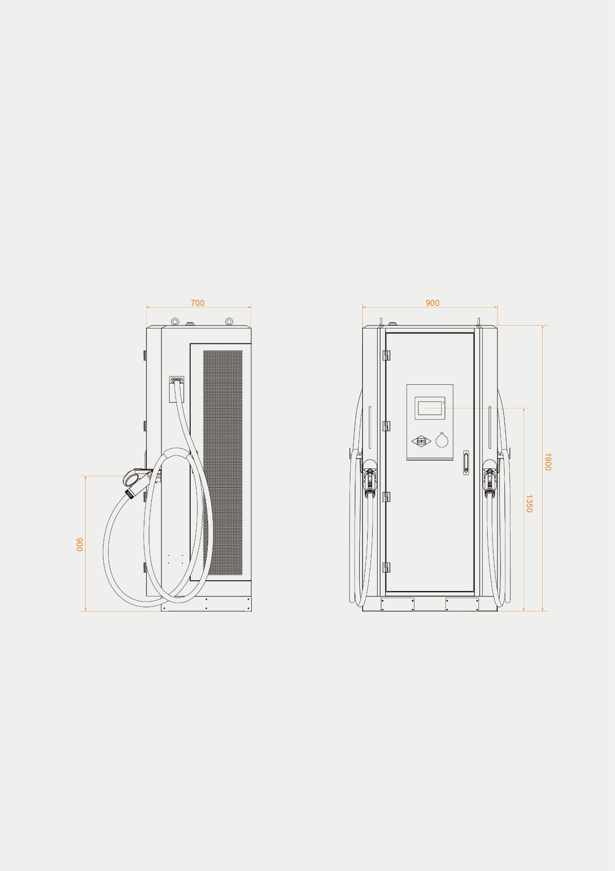
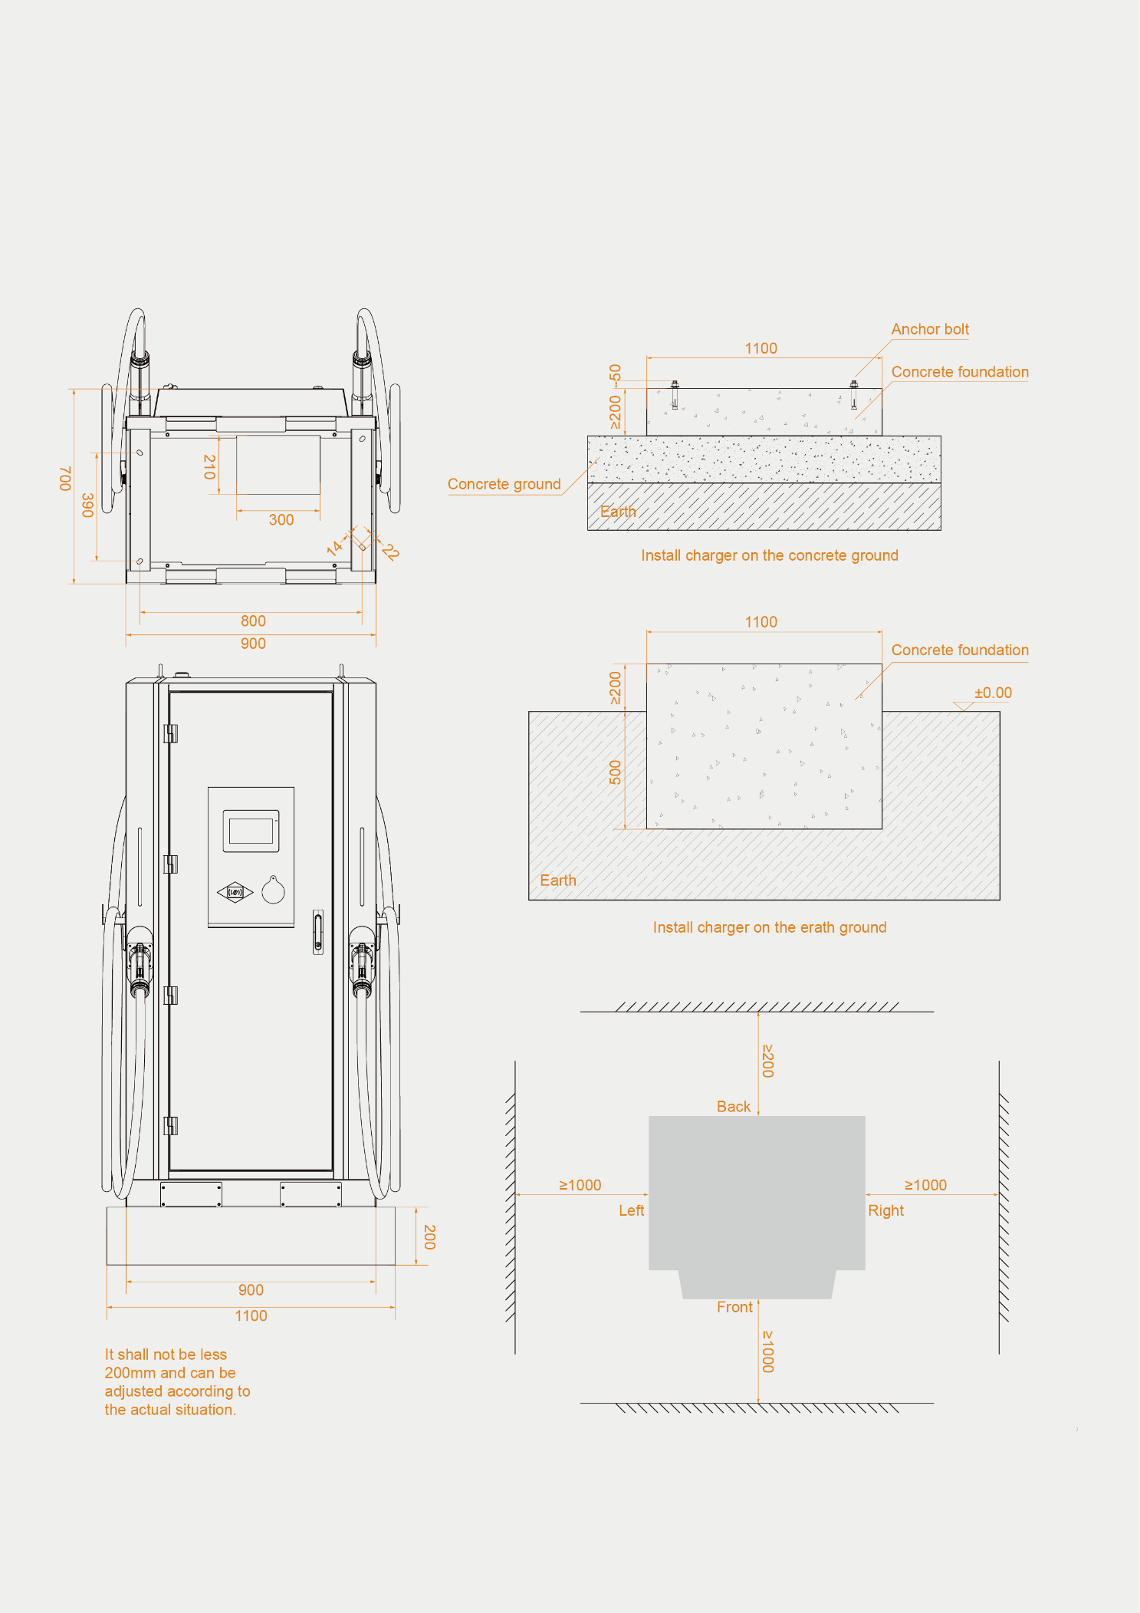
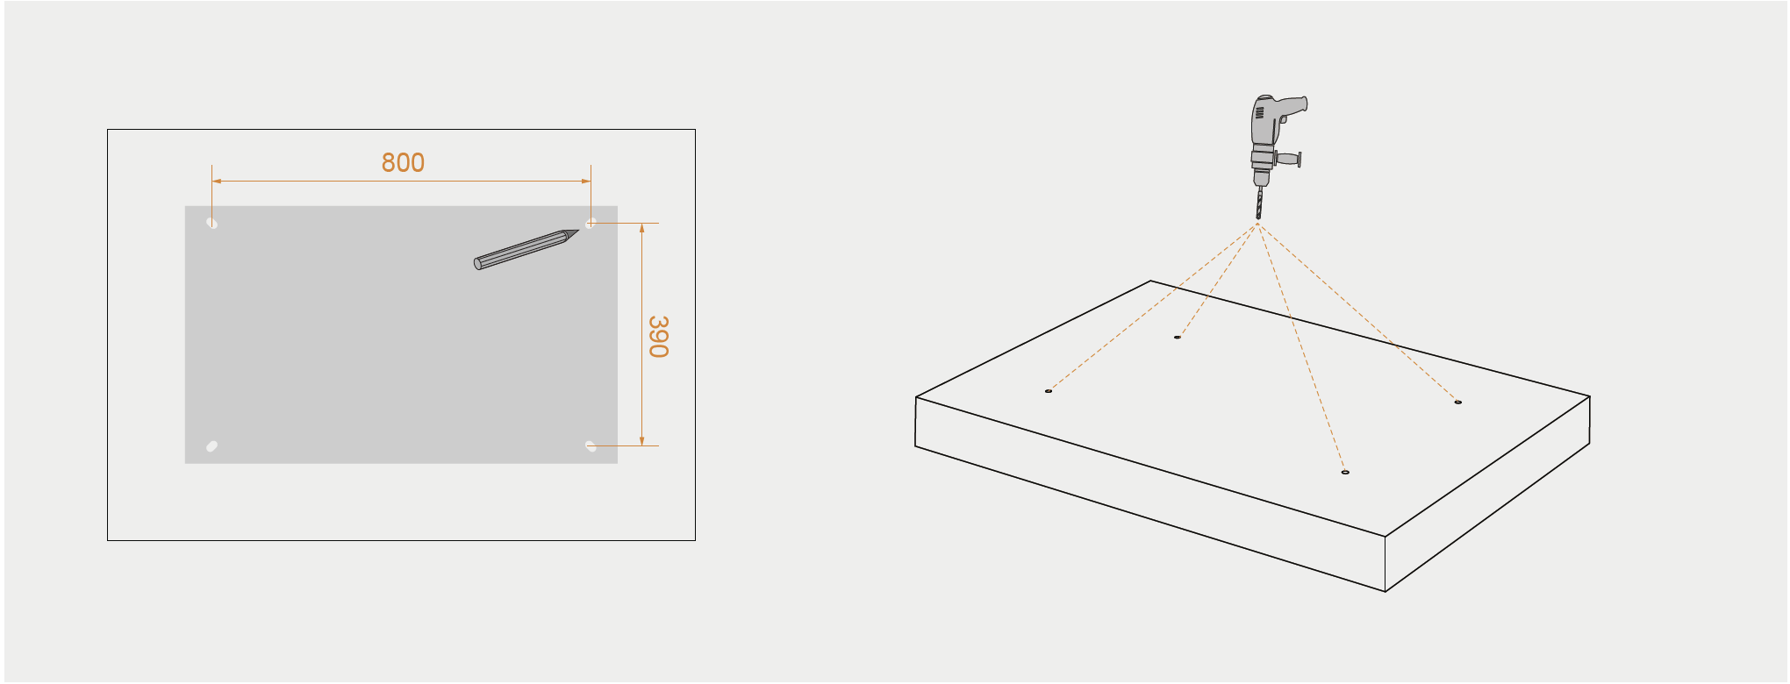
Mark the foundation with a pen based on the size of the bottom, as shown above. | Drill four holes at the marked locations.
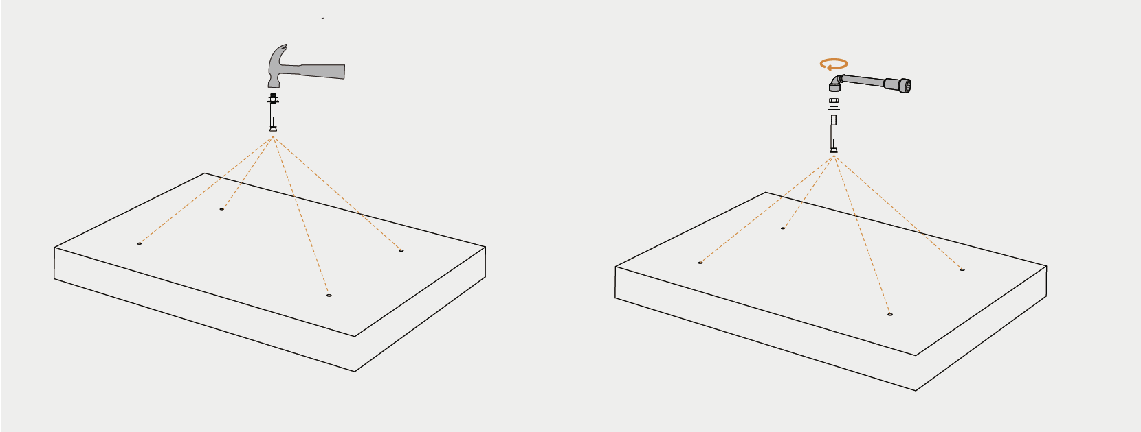
Carefully insert the M12*110 anchor bolt into the pre-drilled hole, then proceed to detach the nut and washer.
5.2.2 Equipment Placement
1. Carefully move equipment onto foundation using crane or forklift (maintain balance to prevent tipping).
2. Adjust equipment level, secure anchor bolts with nuts, and apply anti-rust coating.
3. For wall-mounted installation: use spirit level to position on wall, drill holes, install expansion bolts, secure mounting plate, then hang equipment and lock.
 | 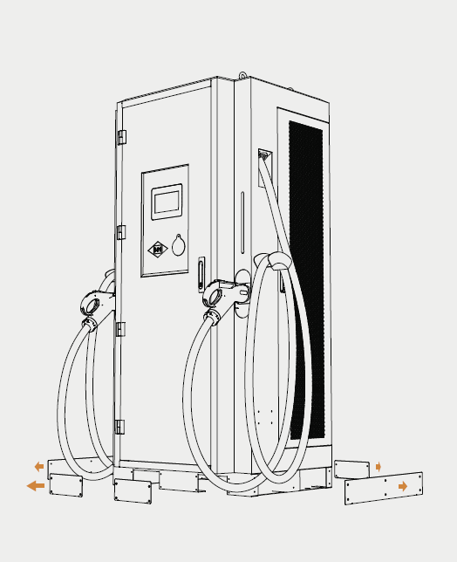
Use a forklift to move the charger onto the foundation.

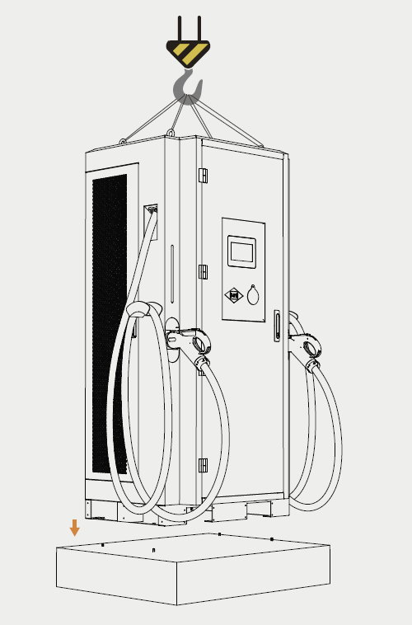 | 
Use a crane to move the charger onto the foundation.
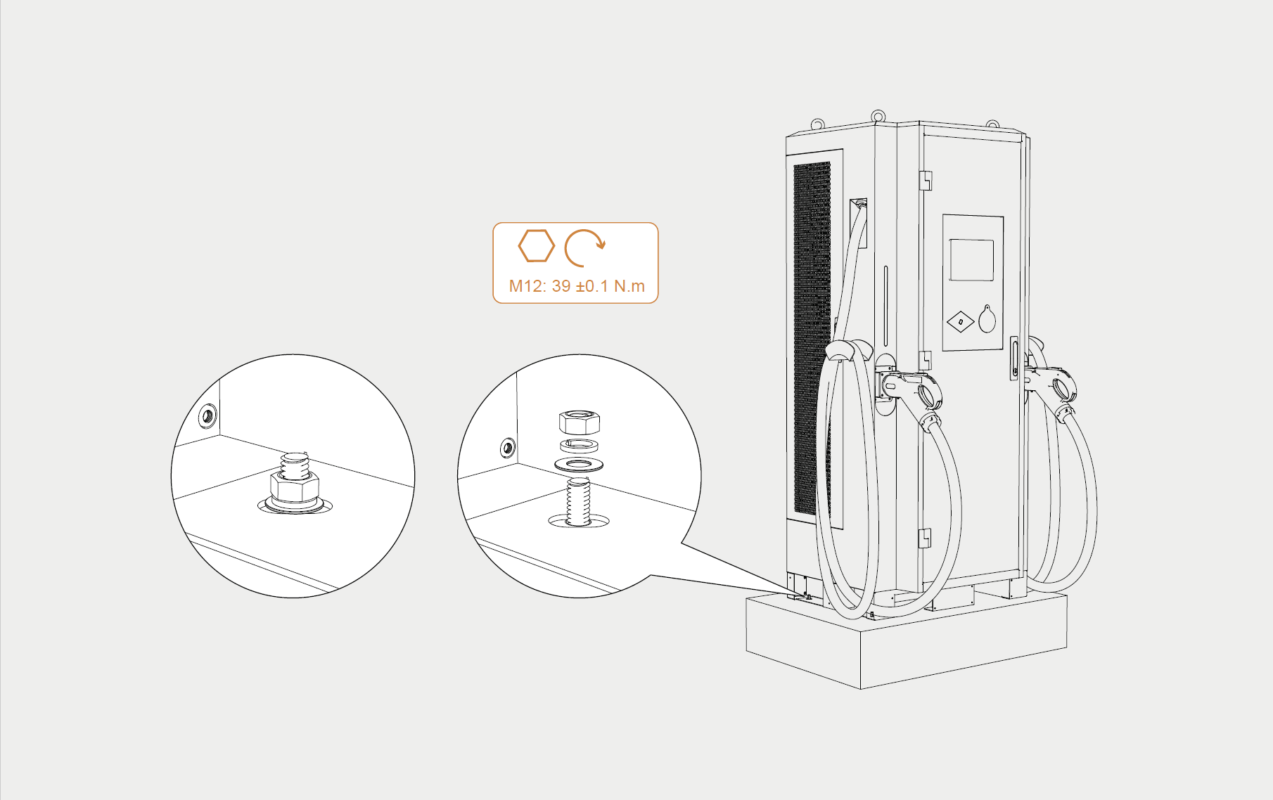
Secure anchor bolts with nuts
5.2.3 Electrical Connection
WARNING: This step must be performed by a certified electrician with power supply disconnected.
1. Open the front or side wiring compartment cover.
2. Route input cable through conduit or cable entry into equipment interior.
3. Strip cable outer sheath to expose appropriate conductor length.
4. Connect cables to corresponding busbars or terminals according to internal wiring diagram and terminal markings:
○ L1, L2, L3: Three-phase live wires (typically brown, black, gray)
○ N: Neutral wire (typically blue)
○ PE: Protective earth (typically green/yellow)
5. Use torque wrench to tighten terminal bolts to specified torque (typically M10 bolts: 20-30 Nm; refer to terminal markings).
6. Gently pull wires to verify secure connection.
7. Organize internal wiring, ensuring no contact with moving parts (e.g., fans) or sharp edges. Use cable ties.
8. Connect communication lines (Ethernet or 4G antenna, if required).
9. After verifying connections, clean work area and close wiring compartment cover.
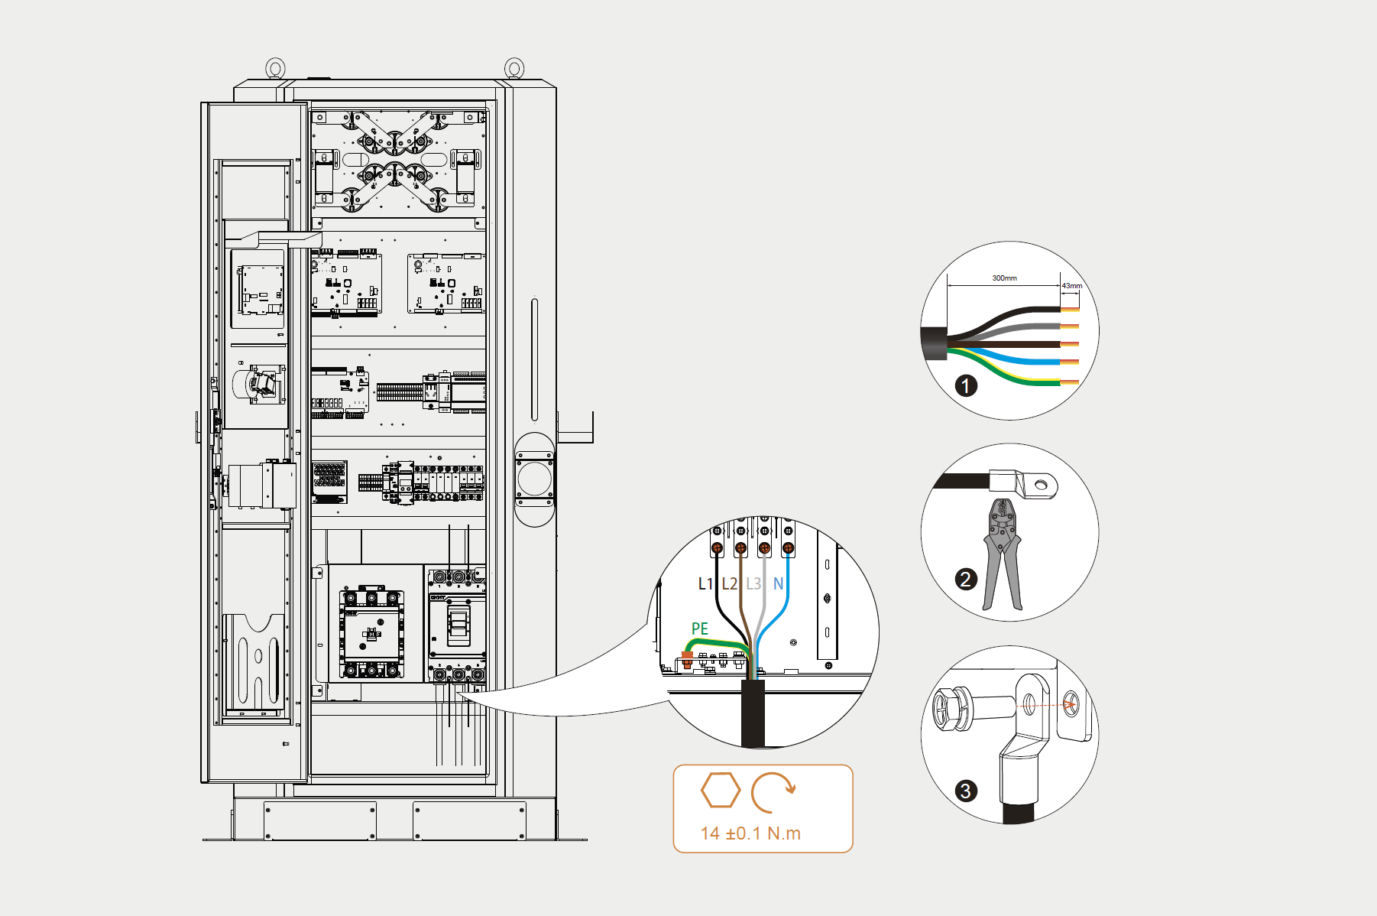

5.2.4 Pre-Power-On Checks
1. Insulation Test: Use a 500V/1000V megohmmeter to measure insulation resistance between input terminals (L1/L2/L3/N) and PE. Should be >5MΩ.
2. Phase Sequence Check: Close upstream breaker and use multimeter to verify normal input voltage at equipment input terminals (400V AC ±15%). Check phase sequence (if phase sequence protection is present, equipment will report error if incorrect).
3. Emergency Stop Check: Verify emergency stop button is in the released (normal) position.
5.2.5 First Power-On Test
1. Ensure all personnel are clear and stand to the side of the equipment.
2. Close upstream breaker.
3. Observe display — should power on. Verify status indicators are normal (typically standby mode, green light steady or flashing).
4. Check fans for smooth operation and abnormal noise.
5. Observe display for any fault alarms. If present, refer to Chapter 10 Troubleshooting.
5.2.6 Functional Test
1. Connect charging gun to test vehicle or dedicated load bank.
2. Initiate charging via card swipe, APP, or screen selection.
3. Verify charging gun locking mechanism functions properly and communication with vehicle BMS is established. Confirm power output begins.
4. Observe voltage and current data on display — should match vehicle demand.
5. Verify no electric shock sensation from equipment enclosure (grounding check).
6. Test stop charging function (via screen/APP/card).
7. Test emergency stop function (pressing should immediately interrupt output).

5.3 Post-Installation Checklist
Check Item | Pass/Fail
Equipment securely installed and level | □ Pass □ Fail
All cable connections tight and secure | □ Pass □ Fail
Ground wire reliably connected | □ Pass □ Fail
Cable entry properly sealed | □ Pass □ Fail
Upstream breaker and RCD correctly rated | □ Pass □ Fail
Insulation resistance test passed | □ Pass □ Fail
Input voltage normal, phase sequence correct | □ Pass □ Fail
Display and indicators function normally | □ Pass □ Fail
Charging function normal (start/stop/output) | □ Pass □ Fail
Emergency stop button functional | □ Pass □ Fail
Communication function normal (if applicable) | □ Pass □ Fail
Fans operate normally, no abnormal noise | □ Pass □ Fail
Basic operation explained to user | □ Pass □ Fail

6. Operating Instructions

6.1 Pre-Charging Preparation
1. Ensure vehicle supports DC fast charging and charging connector matches the station.
2. Check charging gun head for contamination, foreign objects, or damage.
3. Check charging cable for damage or twisting.

6.2 Charging Operation Procedure
Flowchart:
(Start) -> Park & Turn Off -> Remove Charging Gun -> Insert into Vehicle -> Authenticate -> Start Charging -> Charging in Progress -> Stop Charging -> Remove Gun -> Return Gun -> (End)
Detailed Steps:
1. Park and Turn Off: Park vehicle appropriately, turn off ignition or switch to charging state (refer to vehicle manual).
2. Remove Charging Gun: Remove charging gun from the station holster.
3. Connect to Vehicle: Insert charging gun into vehicle DC charging inlet until a "click" sound indicates proper locking.
4. Authentication: Depending on station settings, select one of the following methods to start:
○ Autocharge: For pre-registered vehicles, charging starts automatically after plug-in.
○ RFID Card: Swipe authorized RFID card near reader area; a "beep" confirms recognition.
○ Password: Enter pre-registered password on the charger’s keypad; charging starts after verification.
○ Mobile APP/Mini Program: Scan QR code on screen and select start charging in the APP.
○ VIN/MAC Recognition: System automatically recognizes vehicle VIN/MAC and authorizes charging (requires backend support).
5. Start Charging: After authentication, the charging station communicates with the vehicle BMS/EVCC. Once parameters are confirmed, the contactor closes and power output begins. The screen displays charging voltage, current, energy, time, etc.
6. Monitoring During Charging: Users can monitor real-time charging status via the screen or APP. If abnormalities occur, the equipment will automatically stop and display a fault message.

6.3 Stopping Charging
Normal Stop Methods:
- Via APP/Mini Program: Click "Stop Charging" on the mobile phone.
2. Via RFID Card: Swipe card again at reader (if supported by system).
3. Via Touchscreen: Click "Stop" button on the charging screen.
4. From Vehicle Side: Some vehicles allow stopping charging from inside the car.
● Upon receiving the stop command, the system negotiates with the BMS/EVCC, smoothly reduces current, cuts off output, and unlocks the electronic lock.
Emergency Stop Method:
● Press Emergency Stop Button: In emergencies (smoke, fire, electric shock), immediately press the red “Emergency Stop” button. The equipment will immediately cut off all output.
● Reset: After troubleshooting, rotate the emergency stop button clockwise — it will pop up and reset. The equipment must be re-energized or reset before returning to normal operation.

6.4 Post-Charging Procedure
1. Confirm charging has completely stopped — screen displays "Finished" or similar status.
2. Hold the charging gun handle and remove it from the vehicle inlet.
3. Return the charging gun to the station holster securely. Ensure it is properly seated to prevent water ingress (gun head facing down) or damage.
4. Close the vehicle charging port cover.

7. Description of Indicator Lights, HMI, and Operations Platform

7.1 Status Indicator Lights Description
Indicator | Indicator Status | Equipment Status | Description
 | Blue steady | Standby/Idle | Equipment powered on, normal standby, ready for charging
 | Green flashing | Connected/Authenticating | Communicating with vehicle or waiting for user authentication
 | Green steady/breathing | Charging in Progress | Charging vehicle
 | Red steady | Fault/Alarm | Critical fault, cannot charge — contact service
 | Red steady | Emergency Stop | Emergency stop button has been pressed
Note: Indicator colors and states may vary slightly by model. Refer to screen display and unit markings for confirmation.

7.2 HMI Description
7.2.1 Main Interface / Standby Screen  Welcome message, current time, date.  Equipment status (Idle/Ready).  Charging gun status (Available/Occupied/Fault).  Function entry points: Scan to charge, Swipe card to charge, Inquiry, Settings, etc.  Password:77777777 | 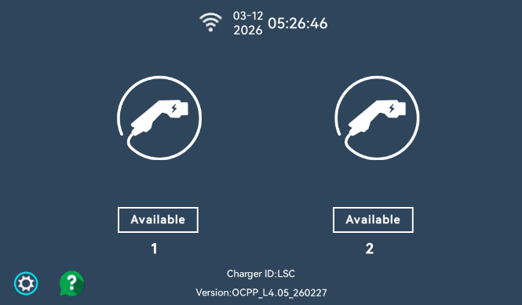  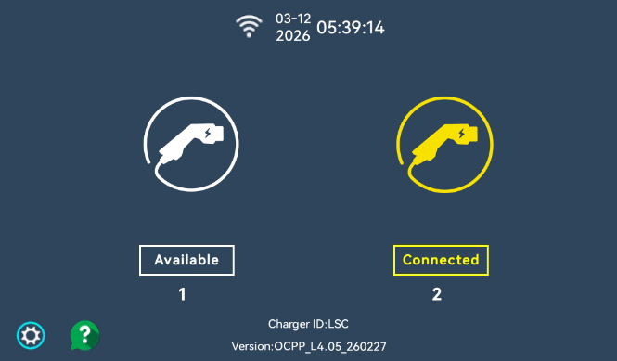  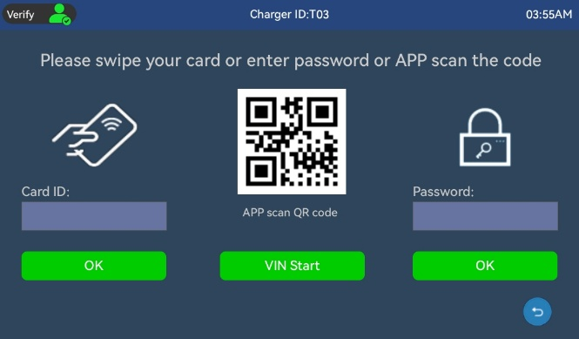  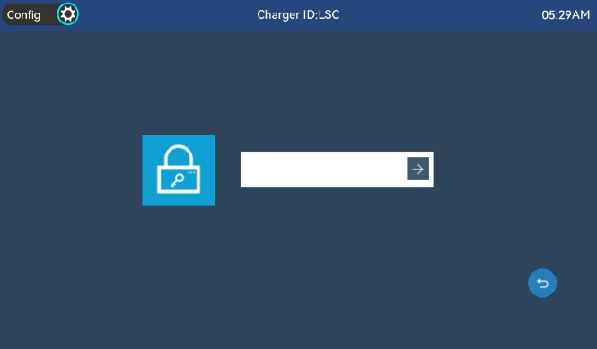
7.2.2 Charging Monitoring Interface  Real-time Data:  Output Voltage (V)  Output Current (A)  Energy Delivered (kWh)  Charging Time (min)  Current Power (kW)  Battery SOC (%)  Status Information: Current charging stage (Constant Current/Constant Voltage/Fully Charged), BMS communication status.  Control Button: Stop Charging. | 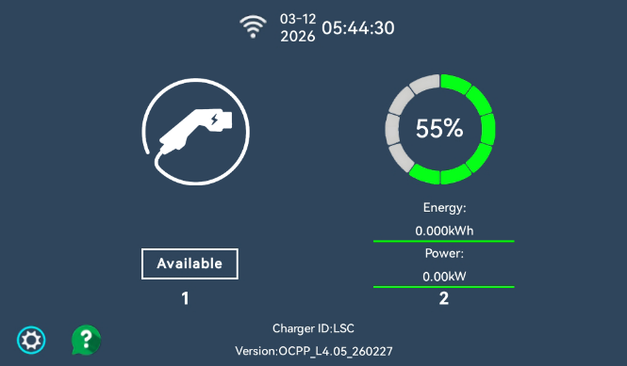  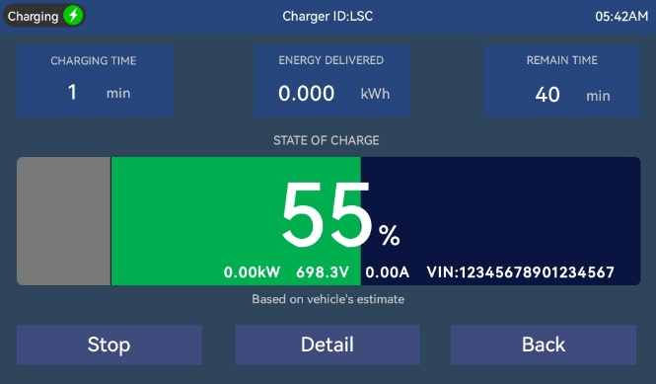  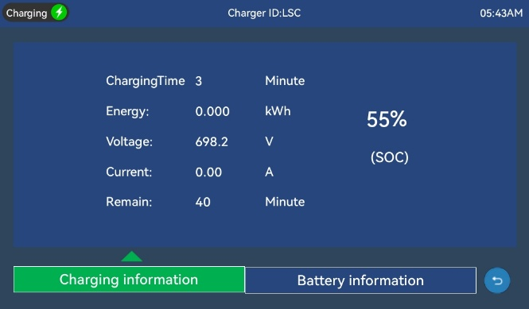  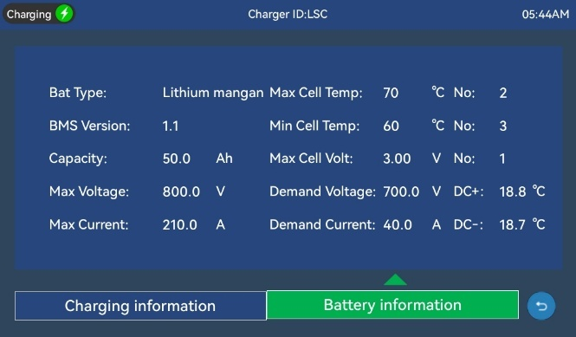
7.2.3 Fault Alarm Interface  Displays current fault codes and brief descriptions.  Displays historical fault records (for service personnel reference). | 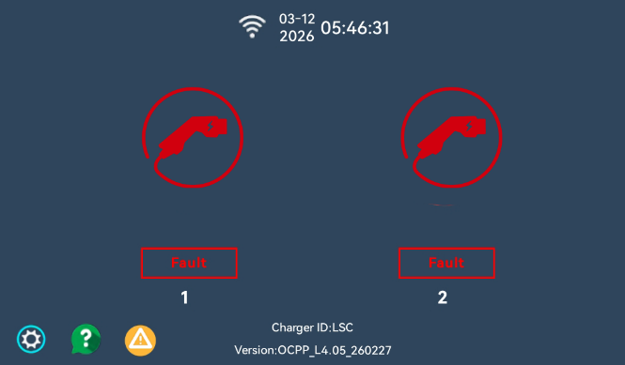  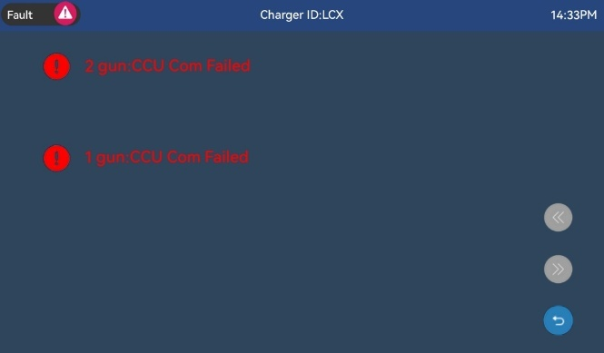
7.2.4 System Settings Interface (Password protected — for professionals only)  Communication parameters (IP address, server address, OCPP parameters, etc.).  System time settings.  Display brightness, language settings.  Meter calibration (authorized access only).  System information (software version, hardware version, serial number).  For the charging station, you only need to set the URL and charger ID. | 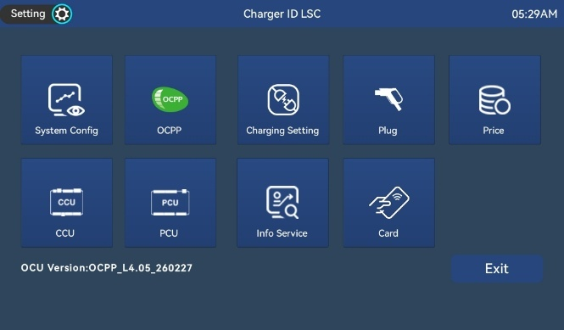  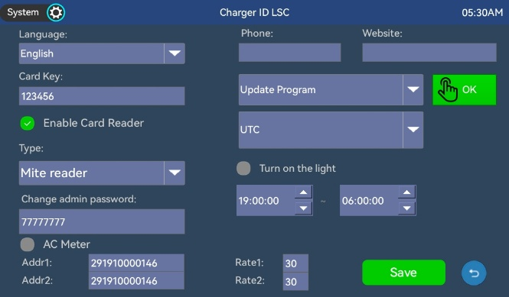  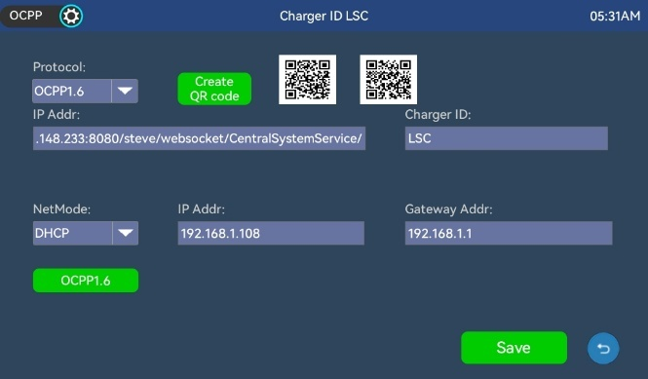  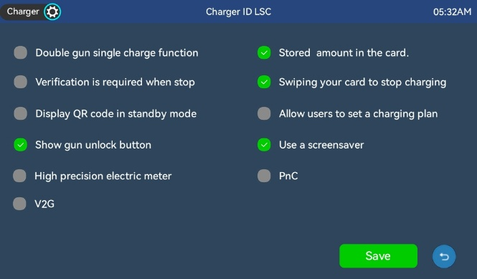  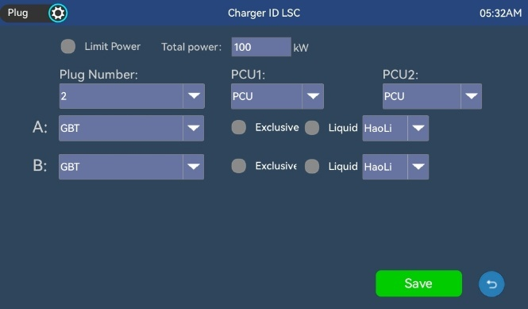  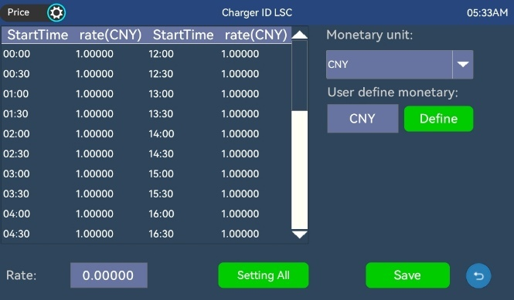  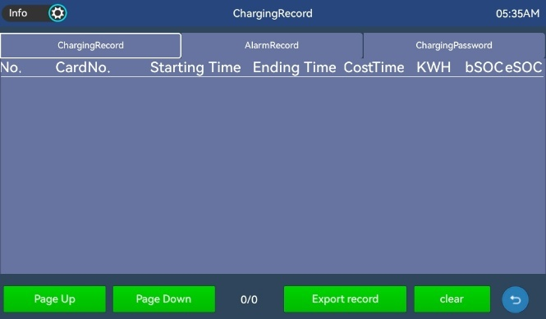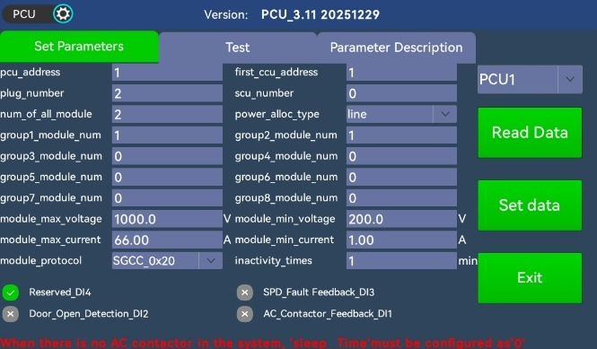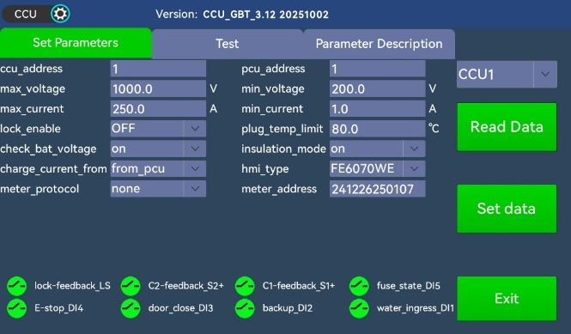  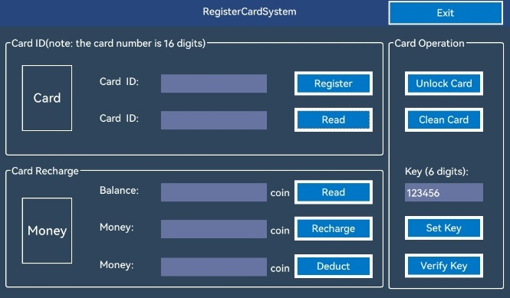

7.3 Operations Platform Introduction
This operations platform is designed to enhance customer service quality. By providing centralized and intelligent management, it ensures stable operation of the charging network, reduces fault response time, and ultimately delivers a more reliable and efficient charging experience for both EV owners and operators.
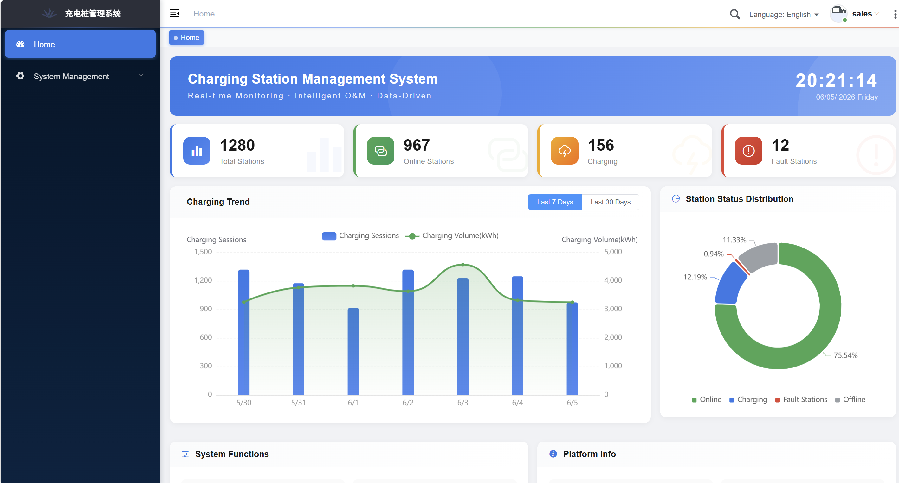
Core functions include:
● Device Monitoring: Real-time view of all charging stations' online status, operating parameters, usage status, and alarm information, with map-based visualization.
● Remote Control: Remote start/stop of charging, device restart, firmware upgrade, and power adjustment, reducing on-site manual intervention.
● Fault Management: Automatic detection of anomalies (e.g., communication failure, over-temperature, over-current, etc.), generation of alarm tickets, and recording of the closed-loop handling process.
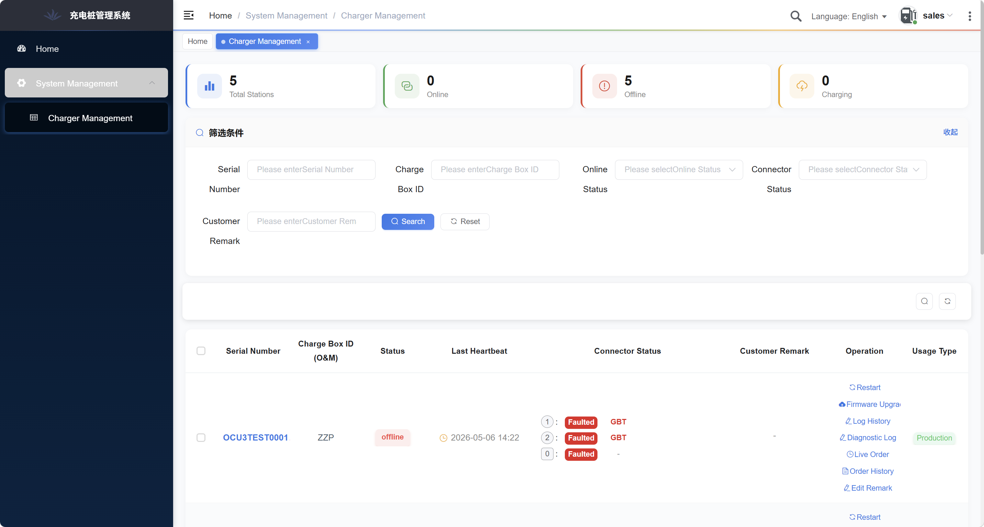
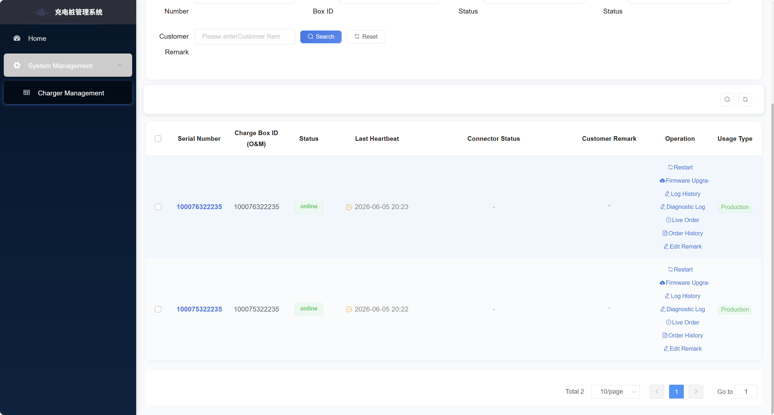
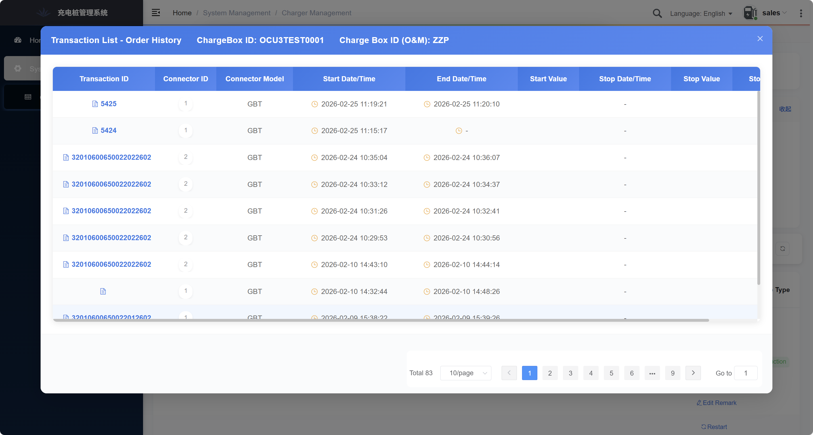
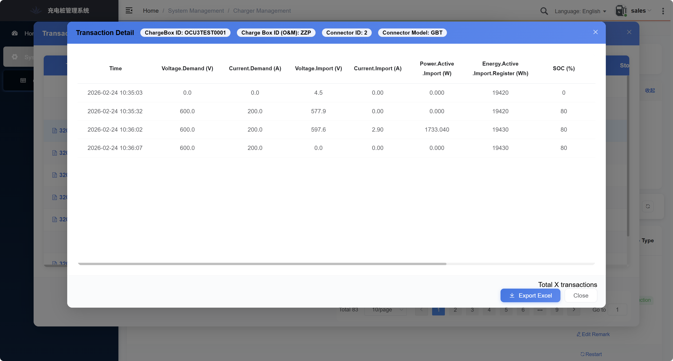

8. Charging Modes Description
This series supports multiple charging modes, depending on backend configuration and vehicle BMS.

8.1 Automatic Charging (Standard Mode)
After plug-in and authentication, the charging station automatically communicates with the vehicle BMS and adjusts output voltage and current according to BMS demand until charging is complete or manually stopped by the user. This is the most commonly used mode.

8.2 Scheduled Charging
Users can set a scheduled charging time via the APP. After plug-in and authentication, the equipment waits until the set time to start charging. Suitable for utilizing off-peak electricity rates.

8.3 Simultaneous and Alternating Charging (Dual Gun Models)
● Simultaneous Mode: When both guns are charging two vehicles simultaneously, the system equally distributes total power to both vehicles. For example, 240kW equipment provides 120kW to each vehicle.
● Smart Allocation/Dynamic Distribution: The system dynamically allocates power based on actual demand from both vehicles. Priority is given to the first connected vehicle; the later vehicle receives remaining power. As the first vehicle's power demand decreases, excess power is allocated to the later vehicle. This mode maximizes equipment utilization.

8.4 Offline Mode
When network communication is interrupted, the equipment can enter offline mode. Supports offline card swiping (whitelist) or Autocharge (VIN-based local authentication). Charging records are temporarily stored locally and automatically uploaded when network connection is restored.

9. Maintenance and Care
WARNING: Before performing any maintenance, disconnect the upstream power supply to the charging station and wait at least 5 minutes for internal capacitors to discharge. When opening the enclosure, use a multimeter to measure DC bus voltage and ensure it has dropped to a safe level (<60V) before contact.

9.1 Daily Inspection (Daily/Weekly — can be performed by operator)
● Visual Inspection: Check enclosure for damage, deformation; verify door locks are intact.
● Indicators/Screen: Verify display and indicator lights function normally.
● Charging Gun and Cable: Check gun head for damage, burning, foreign objects; inspect cable sheath for wear or cracks.
● Emergency Stop Button: Verify it is in the normal released position.
● Fans: Listen for abnormal fan noise.
● Cleaning: Wipe screen and exterior surfaces with a dry soft cloth. Do not spray liquid cleaners directly.

9.2 Periodic Maintenance (Quarterly/Semi-annually — by qualified technicians)
● Internal Cleaning: Open enclosure and use a vacuum cleaner or dry compressed air (low pressure) to remove dust accumulation, especially around power modules, heatsinks, and fans.
● Connection Check: Inspect all wiring terminals (input, output, ground) for looseness or oxidation. Retighten with a torque wrench.
● Component Inspection: Visually inspect internal components (contactors, relays, circuit boards) for discoloration, burning, deformation, or leakage.
● Fan Inspection: Verify cooling fans operate normally; clean fan blades. Replace if abnormal noise or reduced speed is detected.
● Waterproofing Check: Inspect enclosure door seals for aging or damage; verify cable entry seals are intact. Check for any signs of water ingress inside enclosure.
● Grounding Check: Measure grounding resistance — ensure compliance with local codes (≤4Ω).
● Protection Function Test: Test emergency stop button function. If possible, test RCD/leakage protection function.

9.3 Handling During Extended Inactivity
● Disconnect upstream power supply.
● Clean equipment inside and out, ensuring dryness.
● Return charging gun to holster and cover with protective cap (if available).
● Periodically (e.g., monthly) inspect equipment status and perform brief power-up (by qualified personnel) to prevent internal component moisture damage.

9.4 Replacement of Wear Parts
● Fuses: Replace only with fuses of identical specifications.
● Charging Gun Connector: If worn or damaged, must be replaced with original or certified compatible parts.
● Fans: At end of service life, replace with identical specification fans by qualified personnel.

10. Troubleshooting
WARNING: For faults involving internal electrical components, or in case of smoke, odor, sparking, or other hazardous situations, immediately press the emergency stop button, disconnect upstream power, and contact qualified service personnel. Do not attempt to repair the unit yourself.

10.1 Common Faults and Troubleshooting
Fault Symptom | Possible Cause | Check and Remedy
Unit dead, screen off | Upstream breaker tripped or off | Check and reset upstream breaker
Unit dead, screen off | Input phase loss or voltage abnormal | Check input voltage with multimeter
Unit dead, screen off | Internal fuse blown | Contact qualified personnel for inspection/replacement
Charging won't start | Emergency stop button pressed | Check and release emergency stop button (rotate clockwise)
Charging won't start | Charging gun not fully inserted/locked | Reinsert gun firmly until "click" heard
Charging won't start | Vehicle/station incompatibility | Verify connector type and communication protocol match
Charging won't start | BMS communication failure | Try reinserting gun or restarting vehicle
Charging won't start | Card/APP authentication failed | Check card permissions or APP account status
Charging stops mid-session | Vehicle BMS stop command (e.g., battery full) | Normal operation
Charging stops mid-session | Grid fluctuation or momentary outage | Check upstream power supply
Charging stops mid-session | Charger overtemperature protection | Check cooling fans, ambient temperature; clean air intakes
Charging stops mid-session | Output overvoltage/overcurrent protection | Possible abnormal BMS request or equipment fault — contact service
Charging current too low/slow | Vehicle BMS demand limitation | Check vehicle settings or battery status (low temperature, high SOC)
Charging current too low/slow | Power sharing (both guns in use) | Check if other gun is active
Charging current too low/slow | Low grid voltage | Check input voltage
Charging current too low/slow | Charger derating (e.g., high internal temp) | Check cooling conditions
Fault code on display | See fault code table below | Refer to code for specific cause and remedy
RCD/GFCI trips | Internal leakage or cable leakage | Disconnect unit, check internal wiring and gun insulation — contact service
RCD/GFCI trips | RCD/GFCI itself faulty | Replace with identical rated RCD/GFCI and test
Touchscreen unresponsive/slow | Screen dirty or wet | Clean screen
Touchscreen unresponsive/slow | System frozen | Try power cycling via upstream breaker

10.2 Common Fault Code Reference
(Note: Specific fault codes and meanings may vary — refer to on-screen display.)
No. | Fault Description | Recommended Action
OCPP（Charge Point Error Code（OCPP））
1 | ConnectorLockFailure | Replug and replug the charging gun to check whether it is damaged.
2 | EVCommunicationError | Restart the device, use a tool to intercept charging messages, and analyze the cause of the fault.
3 | GroundFailure | Check whether the ground wire is in good contact
4 | HighTemperature | After stopping charging for half an hour, restart the device and check if any charging module reports a fault.
5 | InternalError | On-site inspection
6 | OverCurrentFailure | Check whether the meter and shunt matchor damaged
7 | OverVoltage | Check whether the input voltage is normal
8 | PowerMeterFailure | Check whether the energy meter is damaged
9 | PowerSwitchFailure | Check whether the AC contactor is closed normally
10 | ReaderFailure | Check if the card reader is damaged
11 | ResetFailure | Charging and issuing restart instructions
12 | UnderVoltage | Check whether the input voltage is normal
13 | WeakSignal | examine4GIs the module signal normal?
Vendor error code
1 | CCU communication failure | Check if the communication is loose
2 | card-reader communication failure | Check if the card reader connection is loose
3 | Gun connection Failure | Check whether the charging gun head is damaged
4 | Module Hardware Failure | Check if the module is damaged
5 | Module Communication Failure | Check whether the module communication is damaged
6 | Parallel switch fault | Check whether the AC contactor coil is damaged
7 | Discharge circuit fault | Check if the module is damaged
8 | discharge switch adhesion failure | Check if the module is damaged
9 | charge switch adhesion failure | Check whether the DC contactor is closed normally
10 | AC switch adhesion failure | Check whether the AC circuit breaker is closed normally
11 | arrester failure | Check whether the lightning arrester light is on
12 | fuse failure | Check if the fuse is blown
13 | HMI communication timeout error | Check whether the display communication line is in good contact
14 | Door Opened | Check whether the access switch is loose
15 | Emergency Stop Fault | Check if the emergency stop button is pressed
16 | Communication timeout between CCU | Check if the controller communication line is loose
17 | charge error | On-site interception of charging messages
18 | Insulation warning | Restart
19 | input overvoltage | Check whether the AC line voltage is normal
20 | Input undervoltage | Check whether the AC line voltage is normal
21 | Jlcl-2 communication timeout | none
22 | gun temperature inspection timeout | Check whether the charging gun head is damaged
23 | Power Meter Failure | Check whether the DC meter is working properly
24 | Power Meter Failure | none
25 | CCU communication between pile cabinets timeout | none
26 | Transfer switch pulled in fault | none
27 | AC power lose | Restart the power supply
28 | Change over switch off fault | none
Stop reason
29 | gun connection failure
30 | module hardware failure
31 | module communication failure
32 | Parallel switch fault
33 | discharge circuit failure
34 | discharge switch adhesion failure
35 | charge switch adhesion failure
36 | AC switch adhesion failure
37 | arrester failure
38 | fuse failure
39 | HMI communication timeout error
40 | door open
41 | Emergency Stop Fault
42 | power distribution timeout
43 | energy meter communication timeout
44 | battery reverse connection error
45 | battery matching error
46 | BMS communication error
47 | BMS charge preparation timeout error
48 | BMS prohibit charge timeout error
49 | BMS parameter not suitable for this charger
50 | BMS monomer voltage abnormality
51 | battery current over high error
52 | battery temperature over high error
53 | BMS insulation error
54 | BMS connection error
55 | BMS charging voltage over high
56 | insulation failure error
57 | output voltage cannot reach the expected
58 | E-lock not locked
59 | Charging switch not closed
60 | charging gun temperature over high
61 | battery SOC abnormal
62 | Parallel synchronization error
63 | Meter metering jump
64 | meter exceeds 5 degrees
65 | Meter metering stop
66 | BMS - achieve the required SOC target value
67 | BMS - total voltage set point reached
68 | BMS - reaching the set value of monomer voltage
69 | BMS charger abort (CST frame received)
70 | BMS insulation fault
71 | BMS output connector overtemperature fault
72 | BMS element and output connector over temperature
73 | BMS charging connector failure
74 | BMS battery pack over temperature fault
75 | BMS high voltage relay fault
76 | BMS detection point 2 voltage detection faulted
77 | BMS - other faults
78 | BMS - excessive current
79 | BMS - abnormal voltage
80 | BMS - unknown reason

10.3 When to Contact After-Sales Service
If the above troubleshooting steps do not resolve the issue, or if any of the following occur, contact technical support or authorized service provider immediately:
1. Smoke or burning odor from inside the unit.
2. Breaker trips immediately upon closing.
3. Unit enclosure feels electrically charged (electric shock sensation).
4. Display shows a critical fault code that cannot be cleared.
5. Charging gun cannot be removed (electronic lock stuck, manual release ineffective).
6. Any other abnormal condition that cannot be resolved independently.
When contacting after-sales service, please have the following information ready:
● Equipment model and serial number (from nameplate)
● Description of fault symptom and fault code (if any)
● Installation location and contact information

11. Warranty Information

11.1 Warranty Terms
1. This product is warranted against defects in materials and workmanship for a period of [1] years from the date of original purchase (as shown on the invoice or receipt).
2. During the warranty period, for quality issues occurring under normal use as described in this manual, the manufacturer will provide free repair or replacement.

11.2 Warranty Coverage and Limitations
1. The following are NOT covered under this warranty:
2. Faults or damage caused by failure to install, use, or maintain the product in accordance with this manual.
3. Damage caused by force majeure events (lightning, flood, earthquake, fire, abnormal voltage, etc.).
4. Unauthorized disassembly, modification, or repair of the product.
Damage caused by use of non-original or non-specified accessories (e.g., charging guns).
5. Damage to the charger caused by external grid abnormalities or vehicle faults.
6. Normal wear and tear (cosmetic parts, cable sheathing, fans, etc.).
7. Inability to provide valid proof of purchase.

11.3 After-Sales Service Contact Information
Company Name: ____________________
Service Hotline: ____________________
Technical Support Email: ____________________
Official Website: ____________________
Address: ____________________

11.4 Product Information Record
(Recommended: Fill in and keep for reference)
Item | Content
Model
Serial Number (SN)
Date of Manufacture
Date of Purchase
Dealer/Installer
Installation Address

12. Appendix

12.1 Installation Dimension Drawing

12.2 Certification Information
This product has obtained the following certifications:
- CE (Europe)
- CB(Europe)
- CCC(China)

12.3 Glossary of Terms
Term | Explanation
AC | Alternating Current — the form of electricity supplied by the power grid
DC | Direct Current — the form of electricity used by EV batteries
kW | Kilowatt — unit of power, indicates charging speed
kWh | Kilowatt-hour — unit of energy, indicates battery capacity or charging amount
SOC | State of Charge — remaining battery percentage
BMS | Battery Management System — the "brain" that manages and monitors the battery
EV | Electric Vehicle
OBC | On-Board Charger — device inside the vehicle that converts AC to DC
CCS | Combined Charging System — an internationally used DC fast charging standard
CHAdeMO | DC fast charging standard developed by Japan
GB/T | Charging interface defined by Chinese national standards
NACS | North American Charging Standard (formerly Tesla connector)
Type 1 / Type 2 | AC charging interface types defined by IEC 62196
RCD | Residual Current Device — also known as GFCI (Ground Fault Circuit Interrupter)
RCD / GFCI | Leakage protection device (RCD in Europe, GFCI in North America)
IC-CPD | In-Cable Control and Protection Device — the "control box" on portable chargers
OCPP | Open Charge Point Protocol — the "language" for communication between charger and backend system
ISO 15118 | International communication standard enabling "Plug & Charge" functionality
Plug & Charge | Plug in and automatically authenticate/start charging, no card or app needed
V2G | Vehicle-to-Grid — EVs sending power back to the grid
IP Rating | Ingress Protection rating — e.g., IP54 means dust protection level 5, water protection level 4
Emergency Stop Button | Red button that immediately cuts off power in emergencies
Circuit Breaker | Protection switch that automatically trips during overload or short circuit
PE | Protective Earth — ground wire
L / N | Live Wire / Neutral Wire
CE | EU mandatory safety certification mark
UL | Underwriters Laboratories safety certification mark (USA)
FCC | Federal Communications Commission certification mark (USA EMC)
UKCA | UK Conformity Assessed mark — UKCA replaces CE for UK market after Brexit
IEC 61851 | International standard series for electric vehicle conductive charging systems
UL 2202 / 2594 | US safety standards for DC / AC charging stations

